create database CustomerSegmentationdb;
use CustomerSegmentationdb;

CREATE TABLE customers (
customer_id INT,
customer_name VARCHAR(50),
city VARCHAR(50),
age INT,
total_spent DECIMAL(10,2),
number_of_orders INT
);

INSERT INTO customers VALUES
(1, 'Amit', 'Bangalore', 25, 12000, 5),
(2, 'Neha', 'Mumbai', 30, 45000, 12),
(3, 'Raj', 'Delhi', 22, 8000, 3),
(4, 'Sneha', 'Bangalore', 28, 60000, 15),
(5, 'Karan', 'Mumbai', 35, 20000, 7),
(6, 'Pooja', 'Delhi', 27, 15000, 6),
(7, 'Arjun', 'Bangalore', 40, 70000, 20),
(8, 'Meera', 'Mumbai', 23, 5000, 2);

Level 1: Basic Filtering
1. Show all customers from Bangalore

select *from customers where city = 'bangalore';
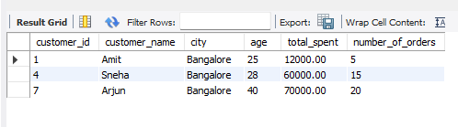
2. Display customers with total_spent > 20000

select * from customers where total_spent > 20000;
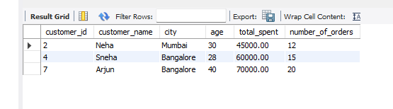

3. List customers aged between 25 and 35

select * from customers where age between 25 and 35;

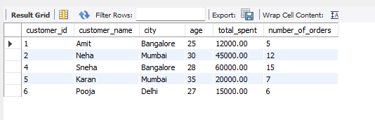
Level 2: Sorting & Aggregation
4. Show all customers sorted by total_spent (highest first)

select * from customers order by total_spent desc;

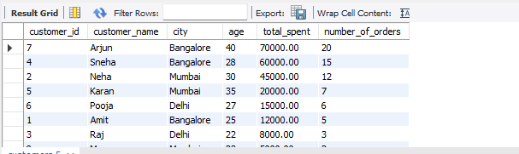

5. Find the total revenue generated

select sum(total_spent) AS tptal_revenue
from customers;
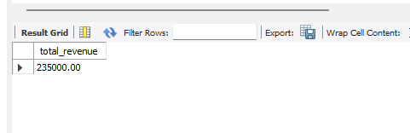

6. Find the average spending per customer

select avg(total_spent) AS average_spending
from customers;

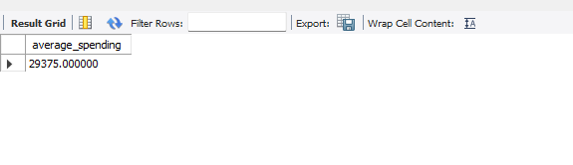
Level 3: Grouping
7. Find total spending per city

select city, sum(total_spent) AS total_spending
from customers
group by city;

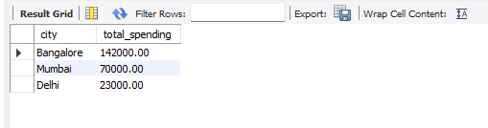
8. Count number of customers in each city

select city, count(*) AS customer_count
from customers
group by city;
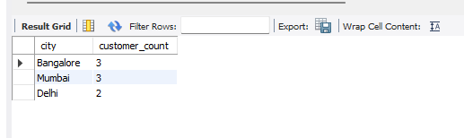

Level 4: Customer Segmentation (CORE TASK )
9.Count how many customers fall into each segment

SELECT
CASE
WHEN total_spent >= 50000 THEN 'High Value'
WHEN total_spent >= 20000 THEN 'Medium Value'
ELSE 'Low Value'
END AS segment,
COUNT(*) AS customer_count
FROM customers
GROUP BY segment;

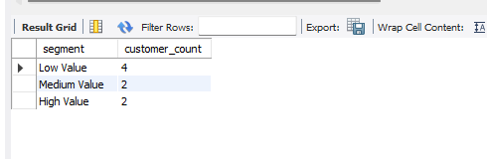

Level 5: Advanced Basic (HAVING)
10.Show cities where total spending is greater than 50000

SELECT
city,
SUM(total_spent) AS total_spending
FROM customers
GROUP BY city
HAVING SUM(total_spent) > 50000;

